DA4DTE Frontend User Guide
Introduction: Welcome to the DA4DTE (Demonstrator Precursor Digital Assistant Interface For Digital Twin Earth) frontend user guide! This document will provide you with a comprehensive overview of the functionalities available in the DA4DTE user interface.

Getting Started:
Upon accessing the DA4DTE application, you will be greeted with an intuitive user interface designed to facilitate seamless interaction with geospatial data through an AI-powered system.

LeafMap Component:
The central component of the DA4DTE interface is the LeafMap, an interactive map interface providing users with an intuitive way to interact with maps and search through a STAC catalog.
To initiate a search, users can simply click on the wrench icon, followed by selecting the STAC icon. From there, they can navigate through collections by clicking on the 'Collections' option, choosing the desired collection, and then selecting individual items. For more refined searches, users can leverage additional parameters, such as drawing a shape directly on the map or specifying search criteria in the 'Additional Params' section.
When conducting searches using these methods, a dedicated 'Results' tab is presented on the left-hand side, showcasing comprehensive details extracted from the STAC items.

Stac search
Here's a detailed breakdown of a simple search:
- Open leafmap menu: Click on the wrench icon in the top right side of the map
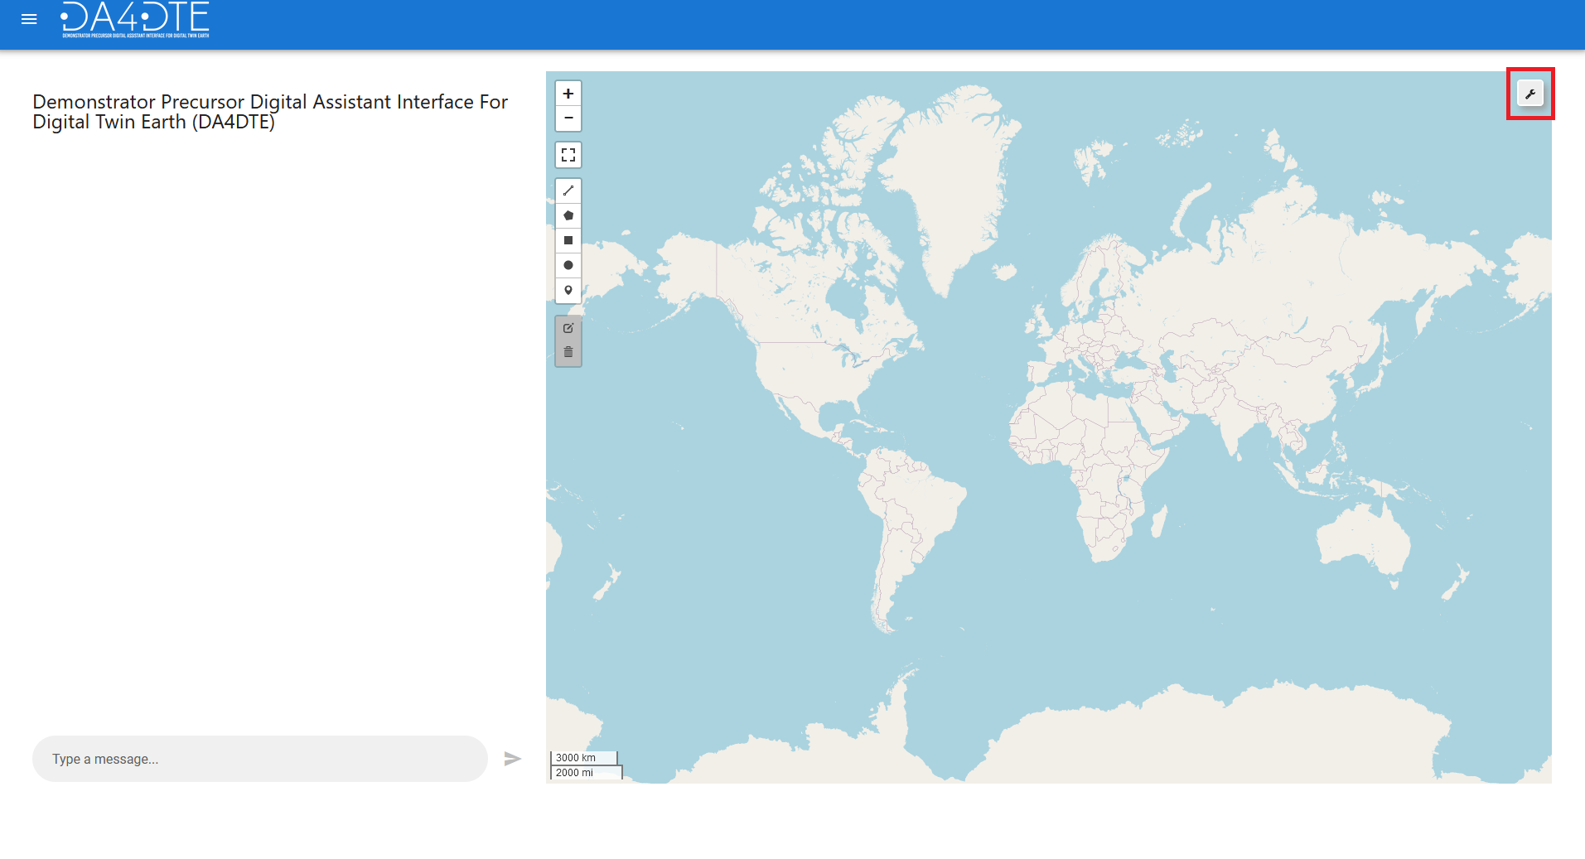
- Click on the stac search icon: to access the STAC search functionality.
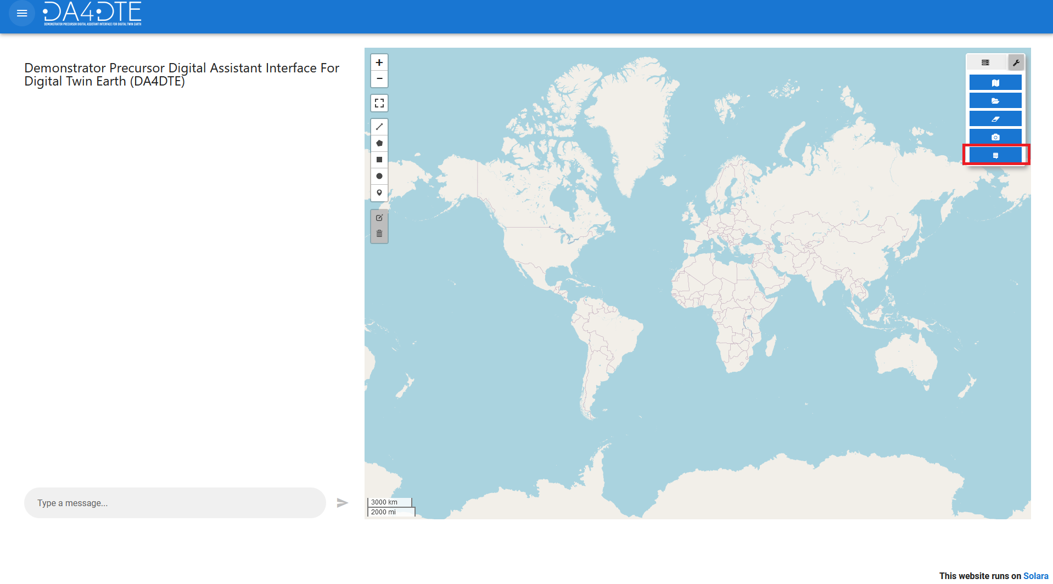
- Click Collection: Click the Collection button.
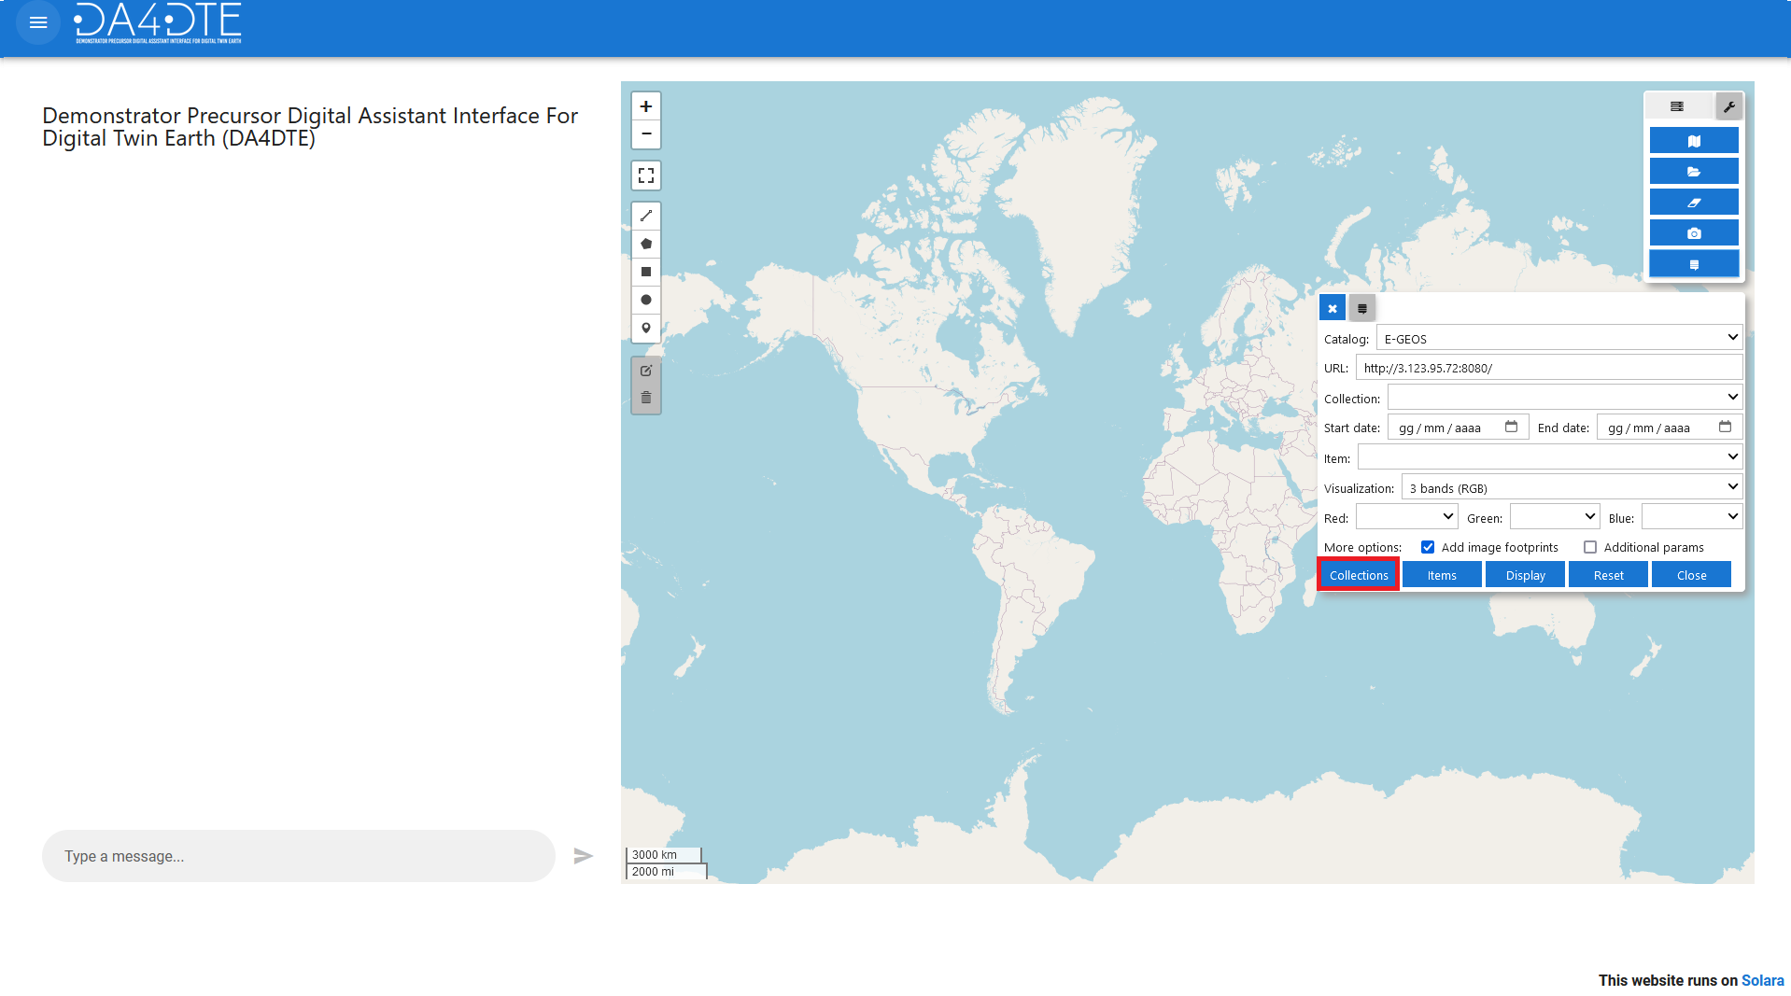
- Select Collection: Select the desired collection in the Collection dropdown.
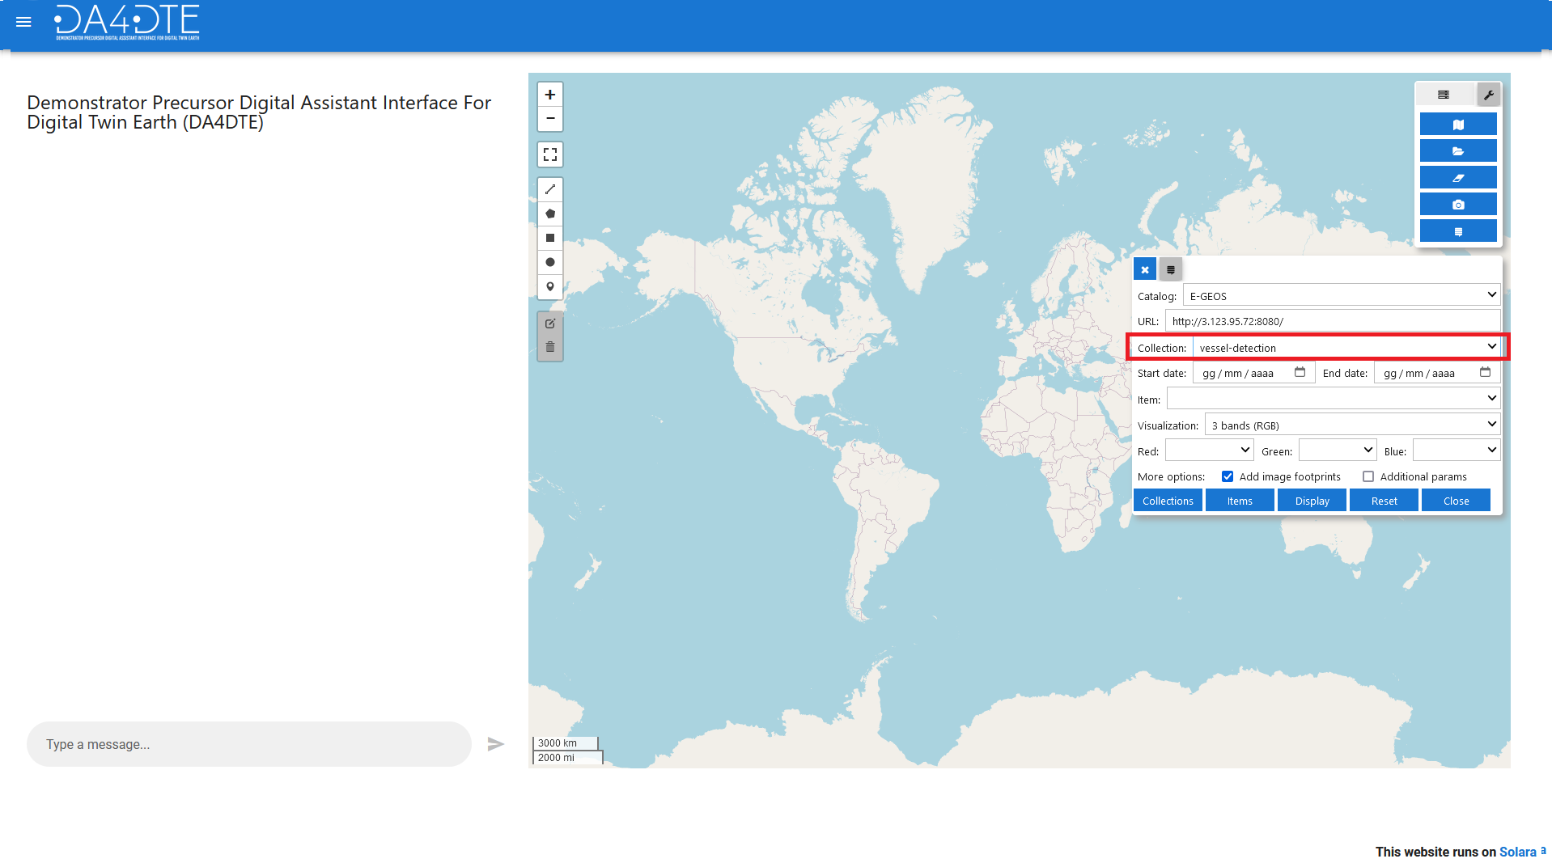
- Select Items: Click on specific items within the selected collection.
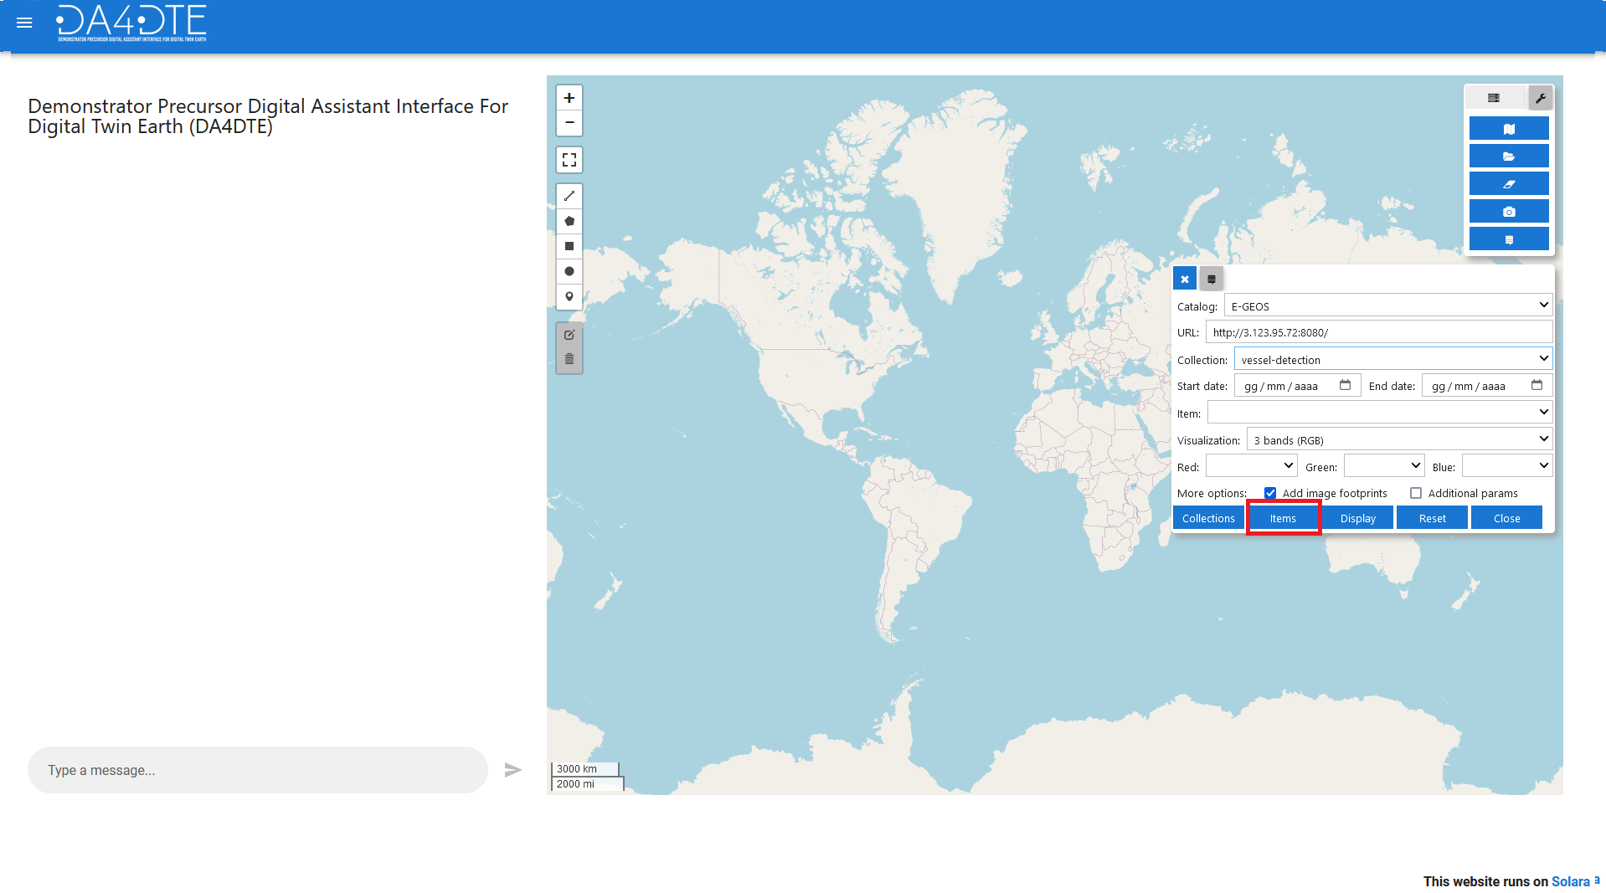
- Visualize results: Observe the query results displayed on the map and in the results table on the left
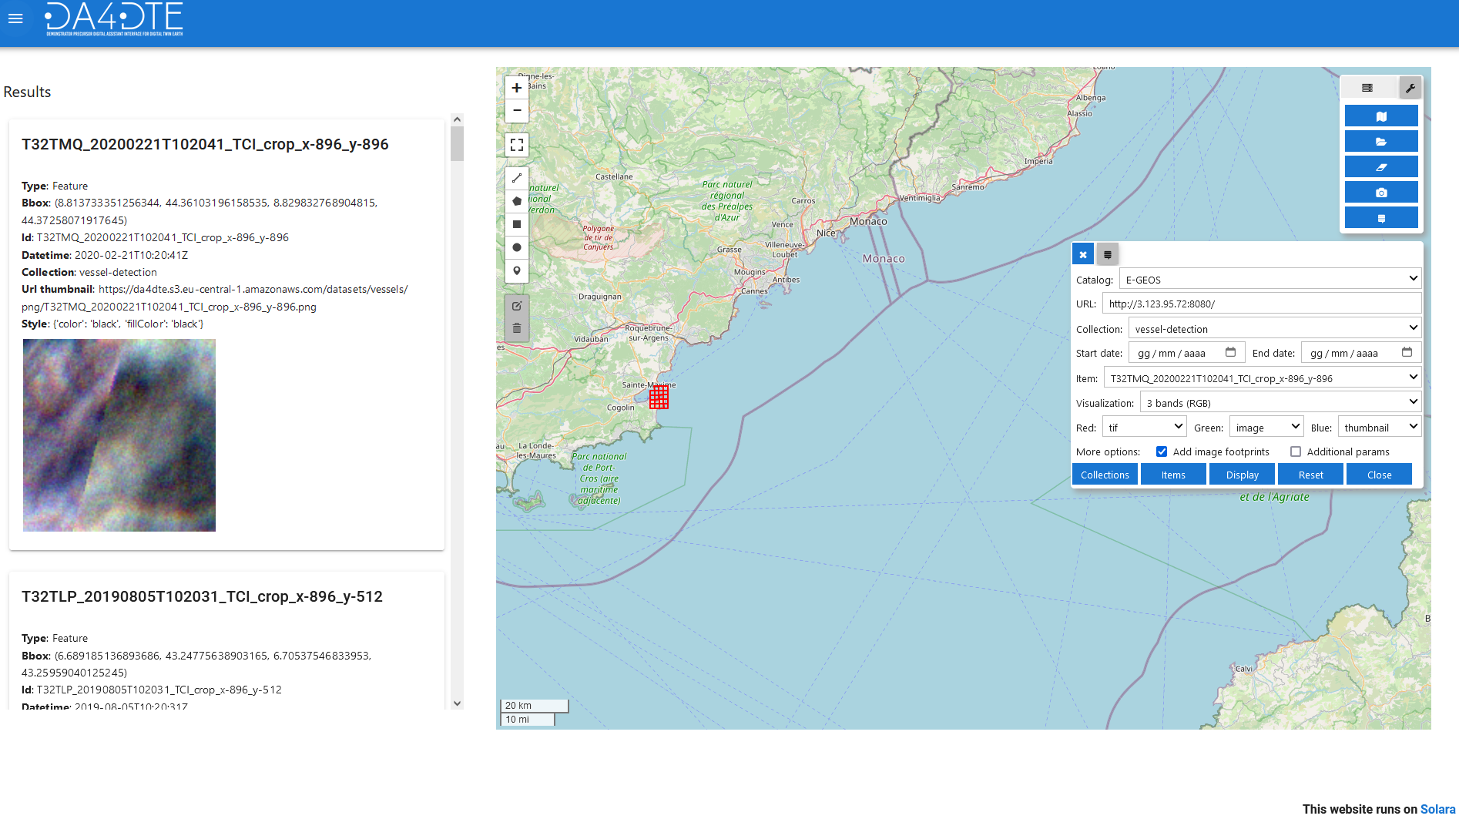
Before clicking the item button it is possible to Customize the search by drawing shapes on the map, using the draw tool, or specifying search parameters in the additional parameters section.
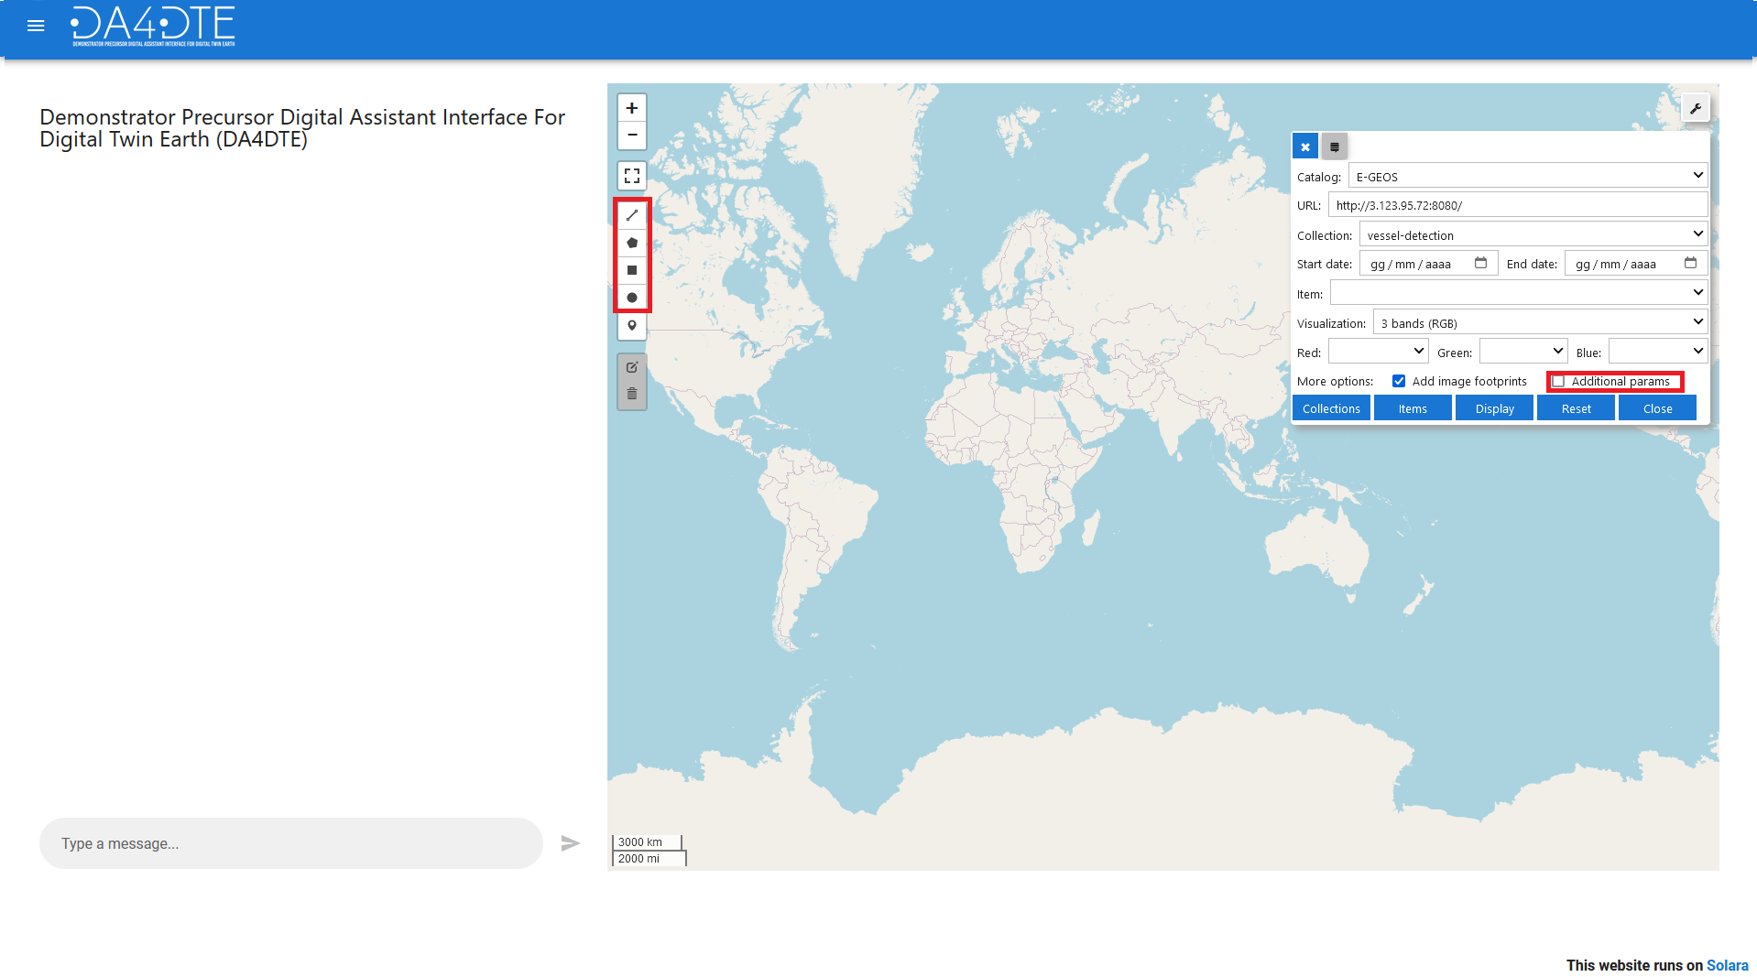

Interaction with STAC Items:
- Selection: Click on an item to select it. The selected item will be outlined in green, and its details will be shown on top of the result tab.
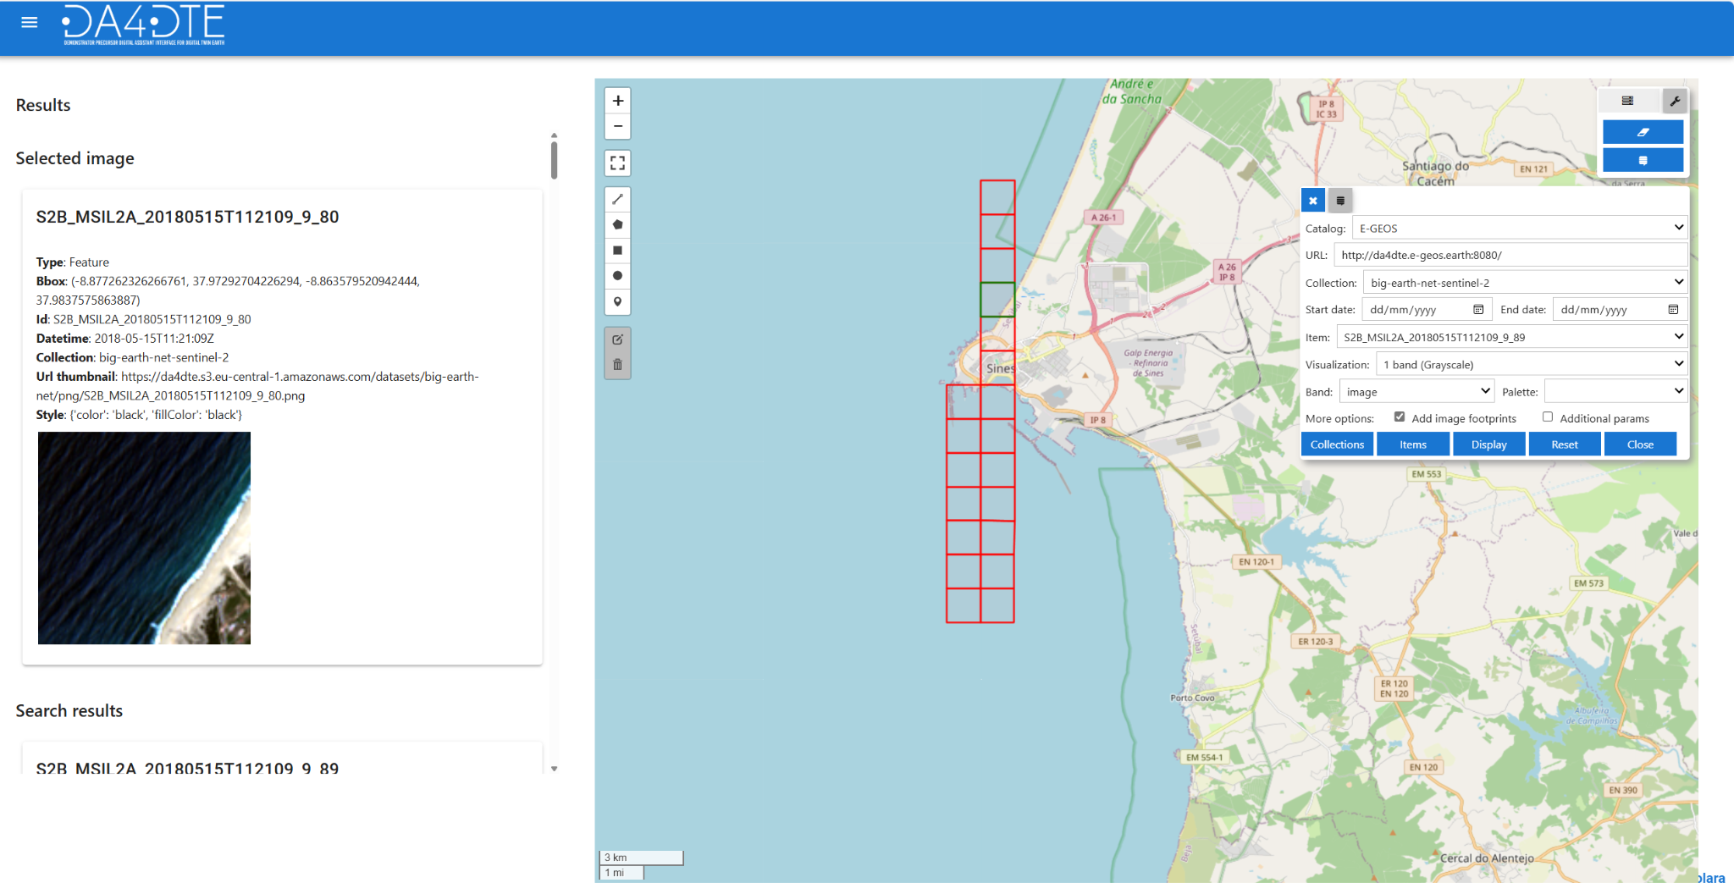
- Parameter for AI Requests: The selected item will be used as a parameter for requests to the AI, such as searching for similar images.
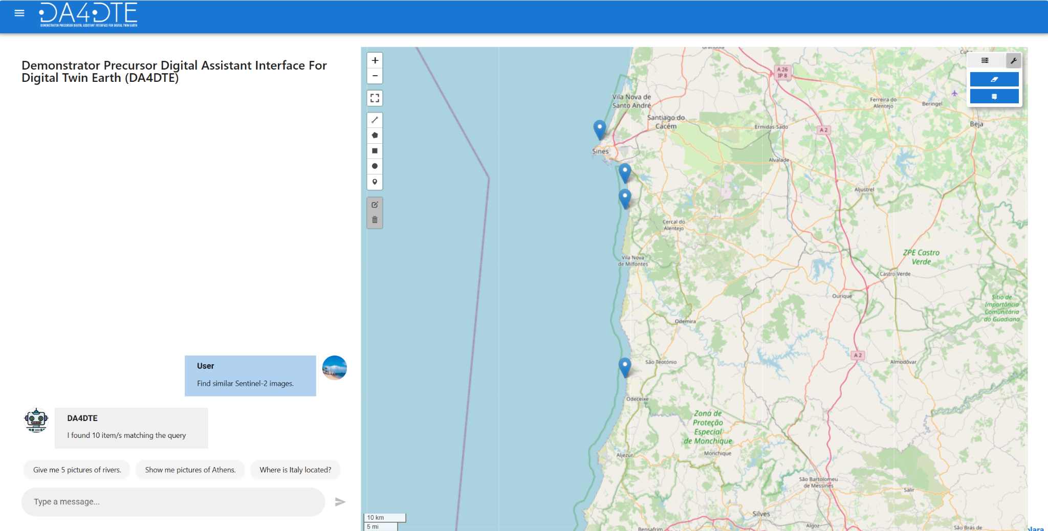

AI Chatbot:
The AI chatbot, located on the left side of the interface, facilitates interaction with the system. Send your queries to the AI chatbot. It will categorize the question and forward the request to the correct engine.
Available Engines:
- Search by Image Engine
- Similarity Explainability
- Image Search by Text
- Binary Visual Question Answering
- Knowledge Graph Question Answering

Engines:
Search by Image Engine: The Image Similarity Engine allows users to find images that are visually similar to a selected image.
Similarity Explainability Engine: The Similarity Explainability Engine provides users with insights into why certain images or data points are considered similar or related.
Image Search by Text Engine: The Image Search by Text Engine enables users to search for images based on textual descriptions or keywords.
Knowledge Graph Question Answering Engine: The Knowledge Graph Question Answering Engine empowers users to ask queries that include image metadata and spatiotemporal constraints.
Binary Visual Question Answering Engine: The Binary Visual Question Answering Engine allows users to pose binary questions about the contents of Sentinel-2 images.
You can see detailed interactions with these engines in the Use Cases Demonstrations section.

Displaying Query Results:
Query results are displayed as follows:
- Map Markers: Results are shown on the map using markers.
- Result Panel: Detailed results are also displayed on the result panel on the left side. When querying the stac catalog or the AI chatbot singularly only the relative images will be displayed, when using both a double tabbed section will be displayed with both query results.

AI results investigation
AI query results are shown as markers on the map, and can be investigated as follows:
- Visualize results: Observe the query and the retrieved images results displayed on the map and in the results table on the left
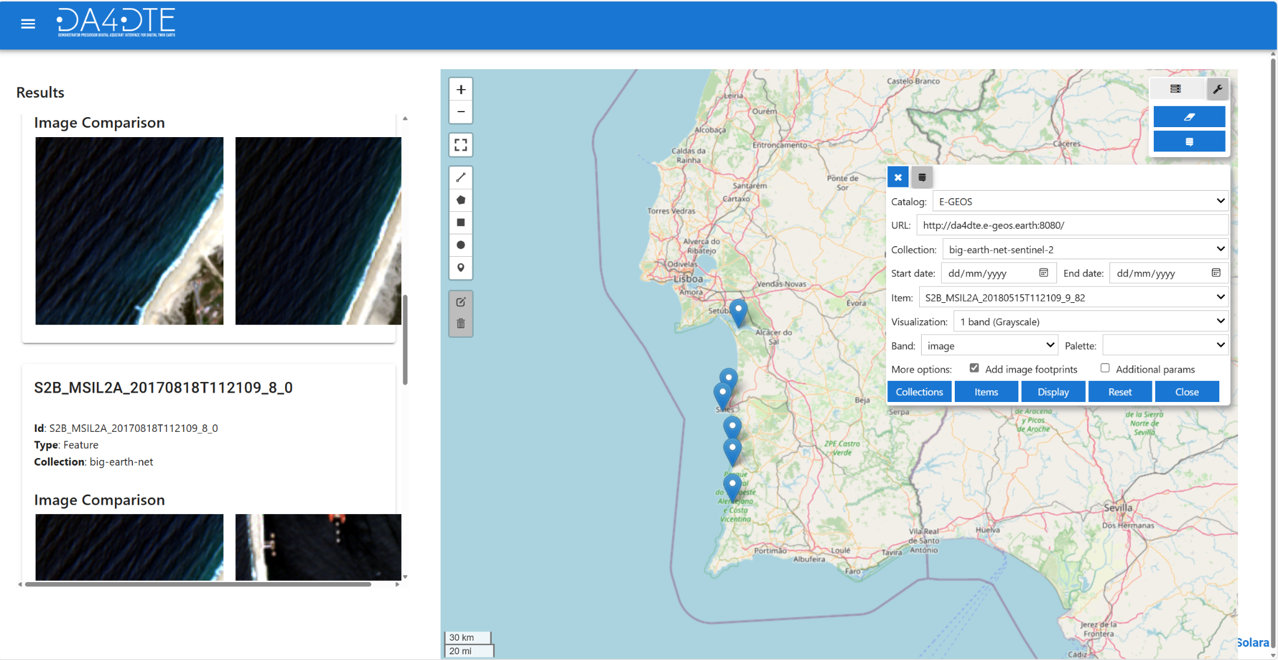

- Selection: Click on a marker to select it. The selected item will be outlined with a green circle, and its details will be shown on top of the result tab.

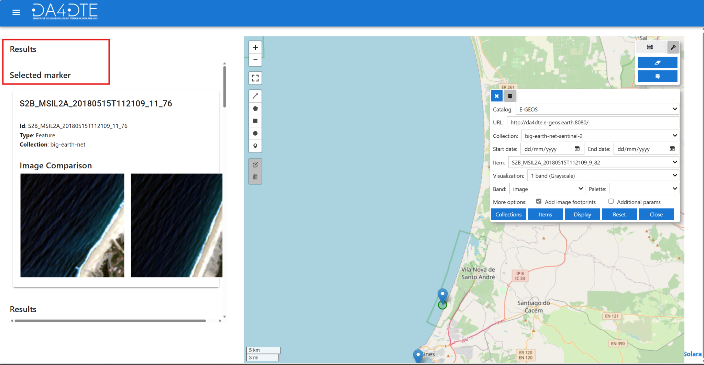

- Selection Indication: Click on a marker to select it. A circle will appear under the selected marker on the map, and the selected item will be shown on top of the result list.
Important!!! The selected marker cannot be used as an input for queries.

Menu Button:
The menu button located on the top left allows users to switch between the results view and the chatbot view. The AI will automatically switch to the results view if deemed appropriate.
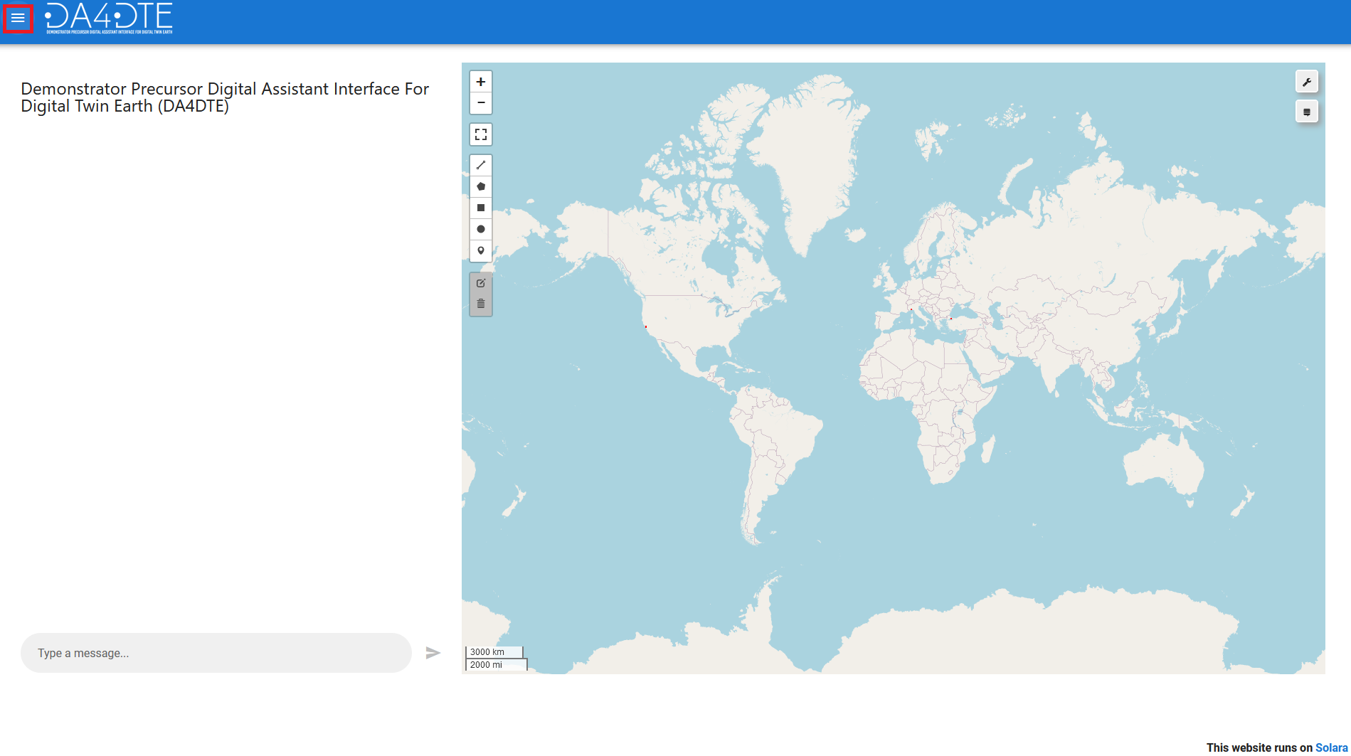

Use Cases Demonstrations:
Textual requests involving image metadata and/or spatiotemporal constraints:
- Request: Write your request in the AI Chatbot panel.
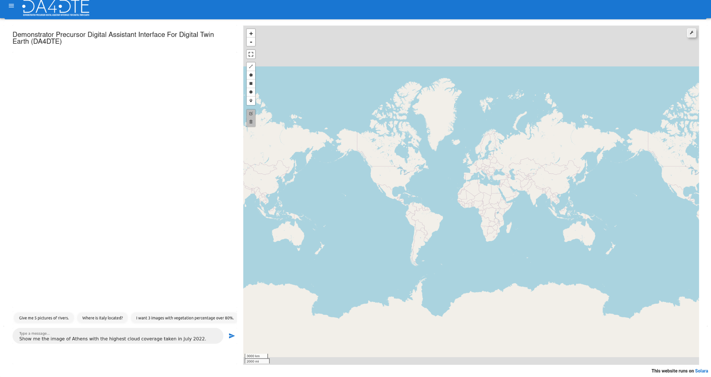
Tip: Your request can include image metadata (cloud coverage, vegetation coverage, snow/ice coverage, VV VH polarization, orbit number, processing level), toponyms in Europe (e.g., Athens, Emilia-Romagna, Belgium), temporal constraints (e.g., “in 2022”, “in a span of 3 days”), administrative divisions (e.g., Municipalities, Towns, Cantons), and spatial constraints (“Images of rivers in Italy”).
- Execution: Press the “Send” button or the “Enter” key to execute the request. Wait for the Knowledge Graph Question Answering engine to process your request and return a response.
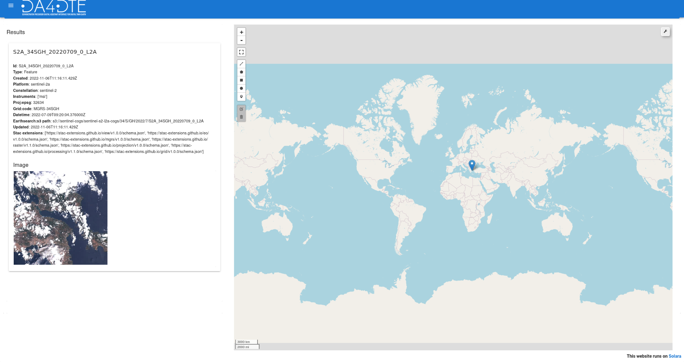
- Results: If the engine found an answer to your request this will be displayed on the map and the side panel.
Textual queries regarding the content of an image:
- Image Selection: Find and select a Sentinel-2 image via a Stac catalog search
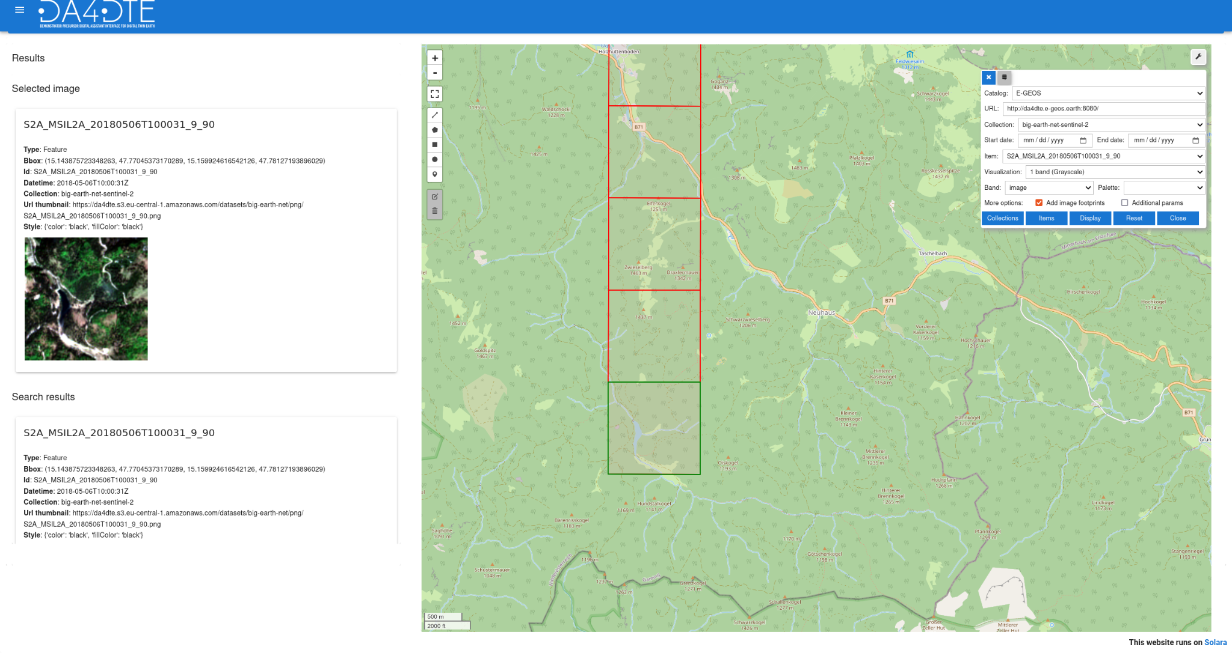
Note: This functionality can’t be used on the Sentinel-2 images which can be retrieved by textual queries.
- Request: In the AI chat panel write a question about the contents of the selected image.
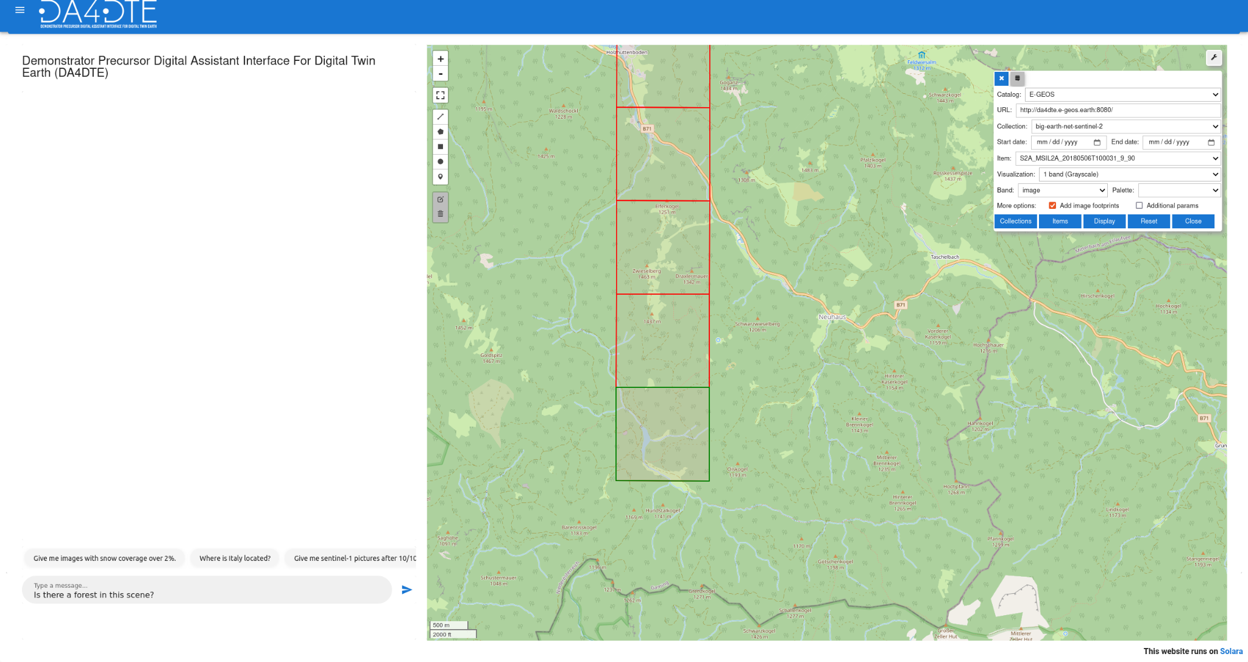
- Response: The Visual Question Answering engine answers your question in the chat panel.
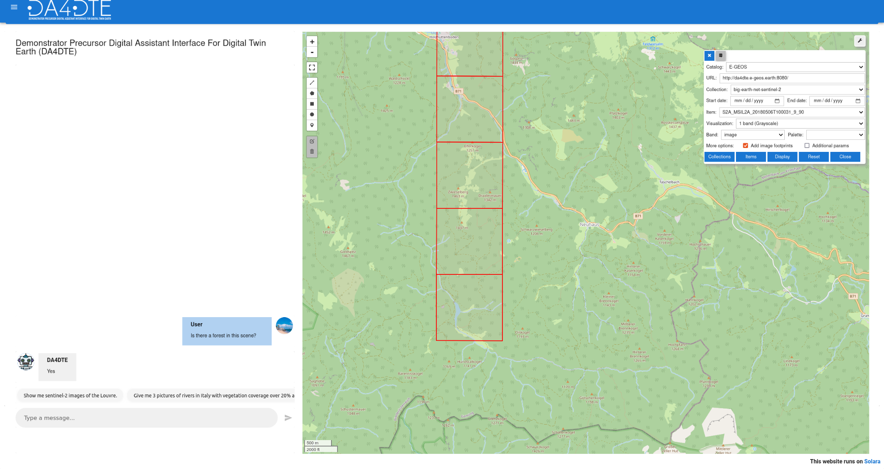

Demonstration on Query by image Engine

One functionality of the digital assistant is to select an image from the user interface and find similar images to the selected image. In this functionality, the user has the option to select as a query an image from Sentinel-1 or Sentinel-2 archive. According to the user’s need the assistant will return the most similar images from Sentinel-1 or Sentinel-2 archives independently on the modality (i.e., Sentinel-1 or Sentinel-2) of the selected query image. This is achieved thanks to the sensor-agnostic retrieval engine that allows querying and retrieving images across different modalities.
Let us assume the user wants to find similar images from the Sentinel-2 image archive to a selected Sentinel-2 image .
- Image Selection: Find and select a Sentinel-2 image via a Stac catalog search
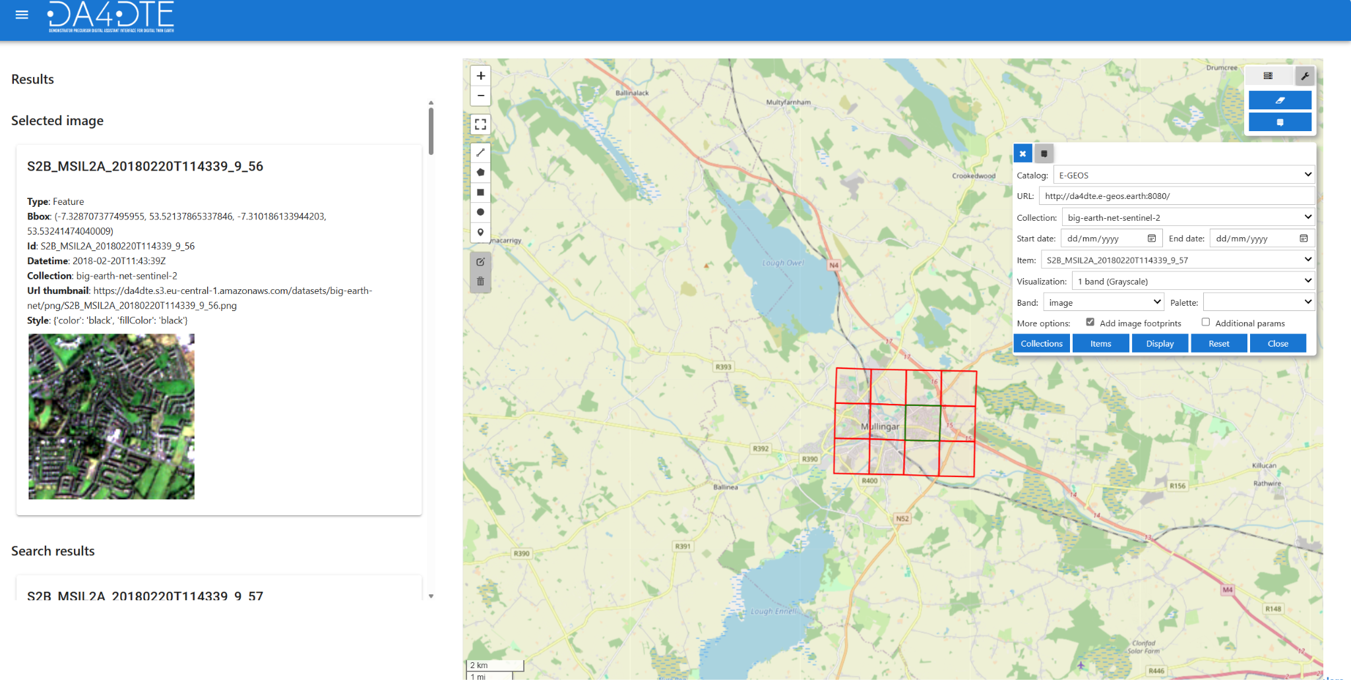

- Request: In the AI chat panel write your request on retrieving similar Sentinel-2 images.

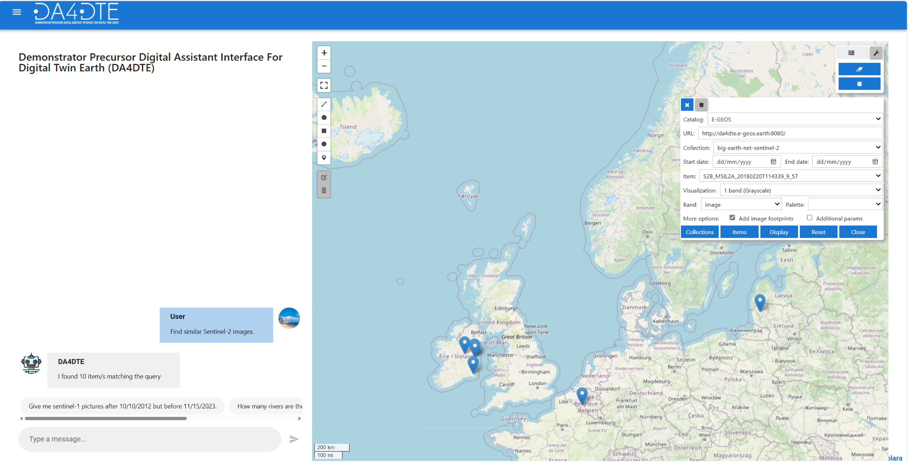

- Response: The Search by image engine returns the similar images.

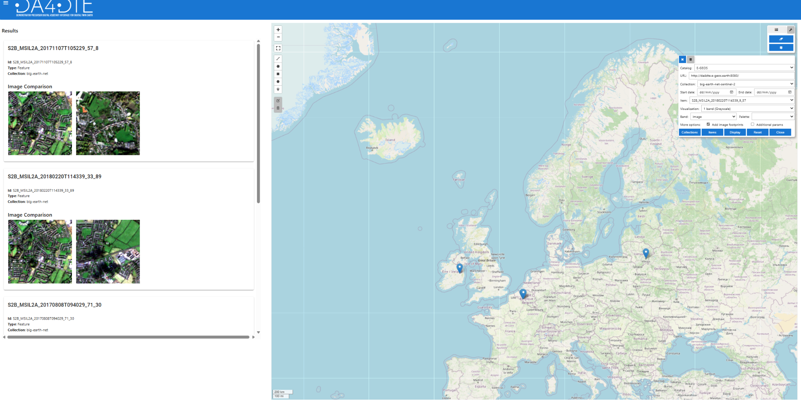

Demonstration on Explainability tool
The user can ask explanations about the engine (i.e., model) decision on returning those images. The user can achieve this by first selecting one image of interest (among the returned ones) and asking explanations about the engine’s decision on retrieving the selected image by typing: ‘’ Explain the decision of the engine in retrieving this image”. Then, the task interpreter will activate the explainability tool which will provide the most probable land use land cover (LULC) classes present in the selected image along with the explanations (i.e., the heat maps for each class) motivating the decision of the engine in retrieving the selected image.
- Image Selection: Select one image among the retrieved ones
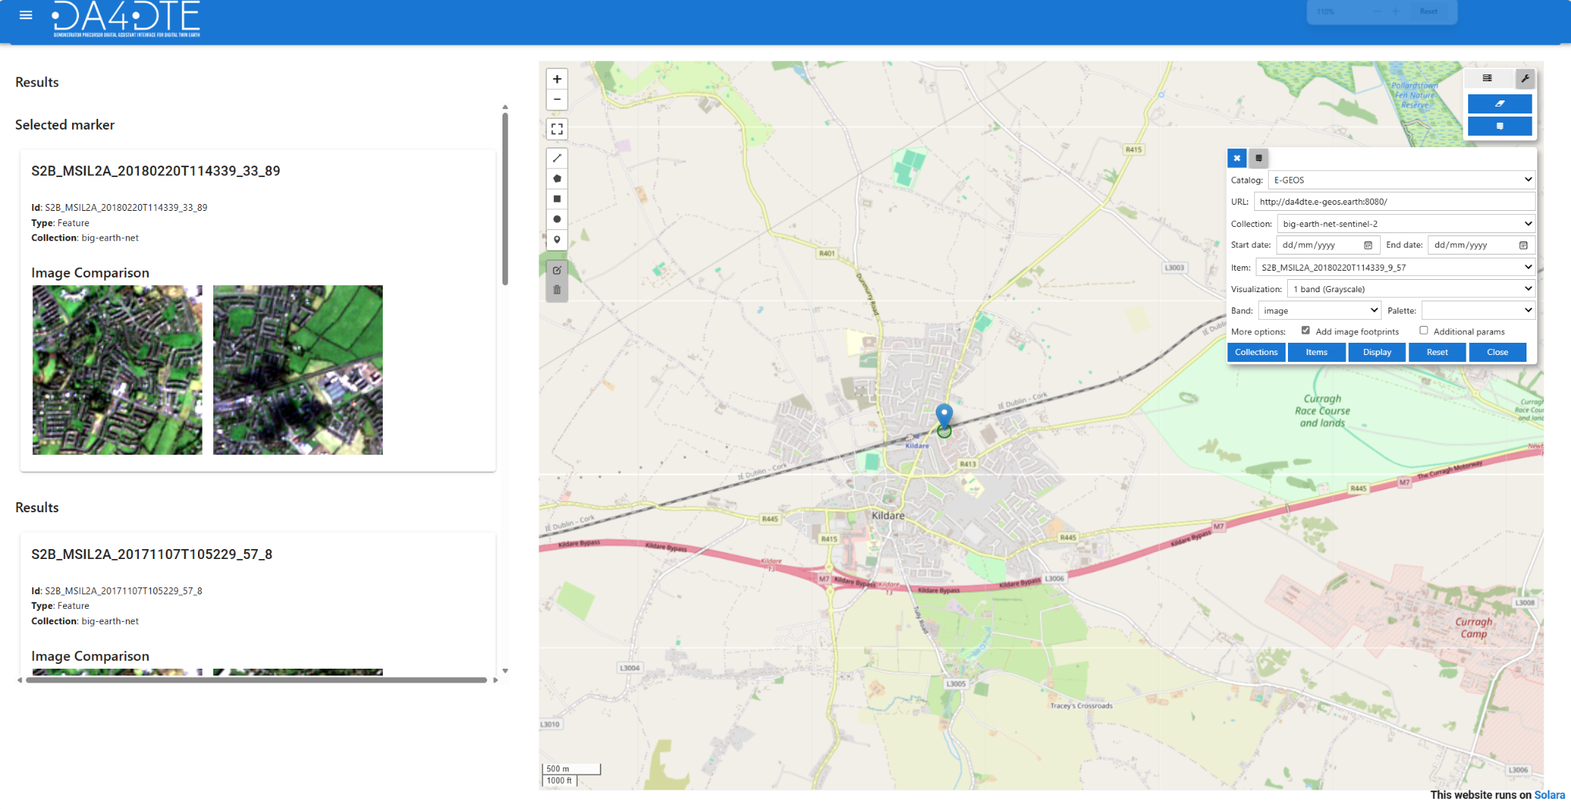

- Request: In the AI chat panel write your request to ask explanations about the engine’s decision on retrieving the selected image.
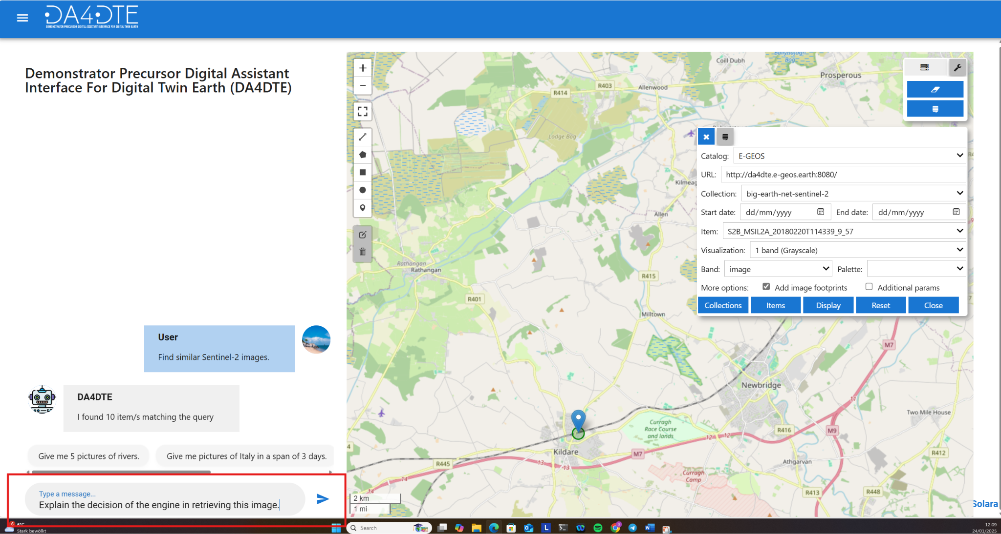

- Response: The explainability tool provides the most probable land use land cover (LULC) classes present in the selected image along with the explanations (i.e., the heat maps for each class) motivating the decision of the engine in retrieving the selected image.
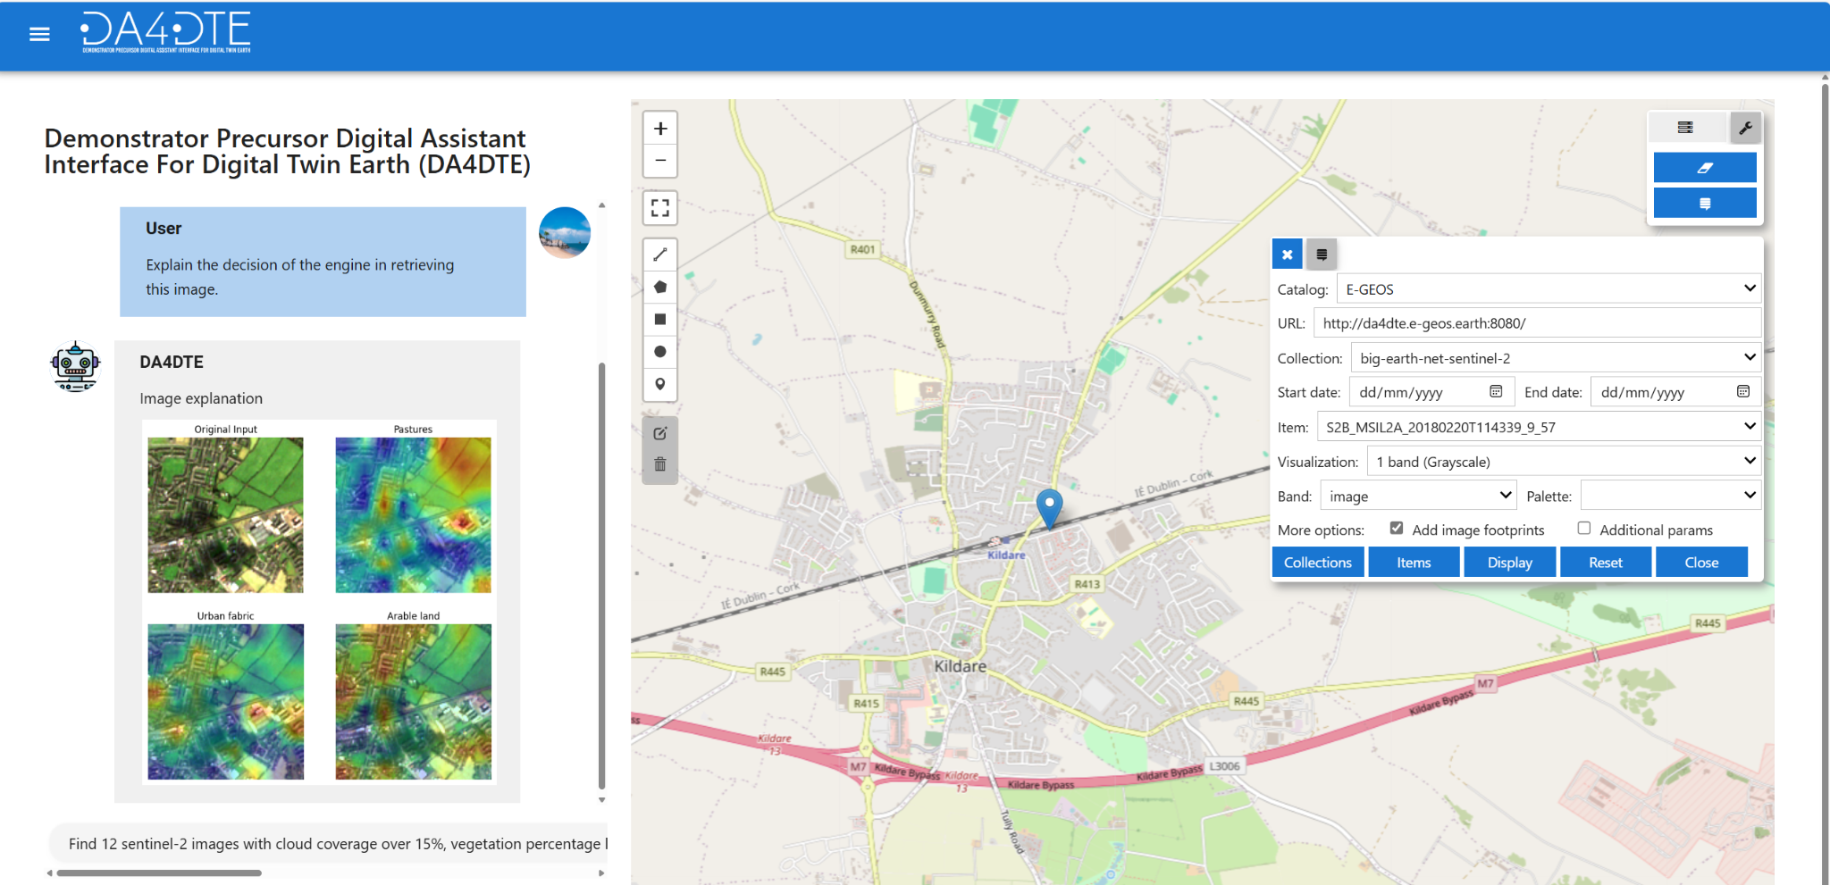

Demonstration on Query by text Engine
An additional feature of the digital assistant is querying for images containing vessels using textual descriptions (i.e., captions). In this case, the user can formulate the query utilizing natural language to retrieve the images containing vessels. To perform this task, the query by caption engine will be activated returning similar images to the query text. The users can specify features like the number and the size of the vessels as well as their location (i.e. in a harbour or near the coast). For illustration let us consider an example where the user asks for images containing many vessels near the coast.
- Request: In the AI chat panel write your request to ask for many vessels near the coast.
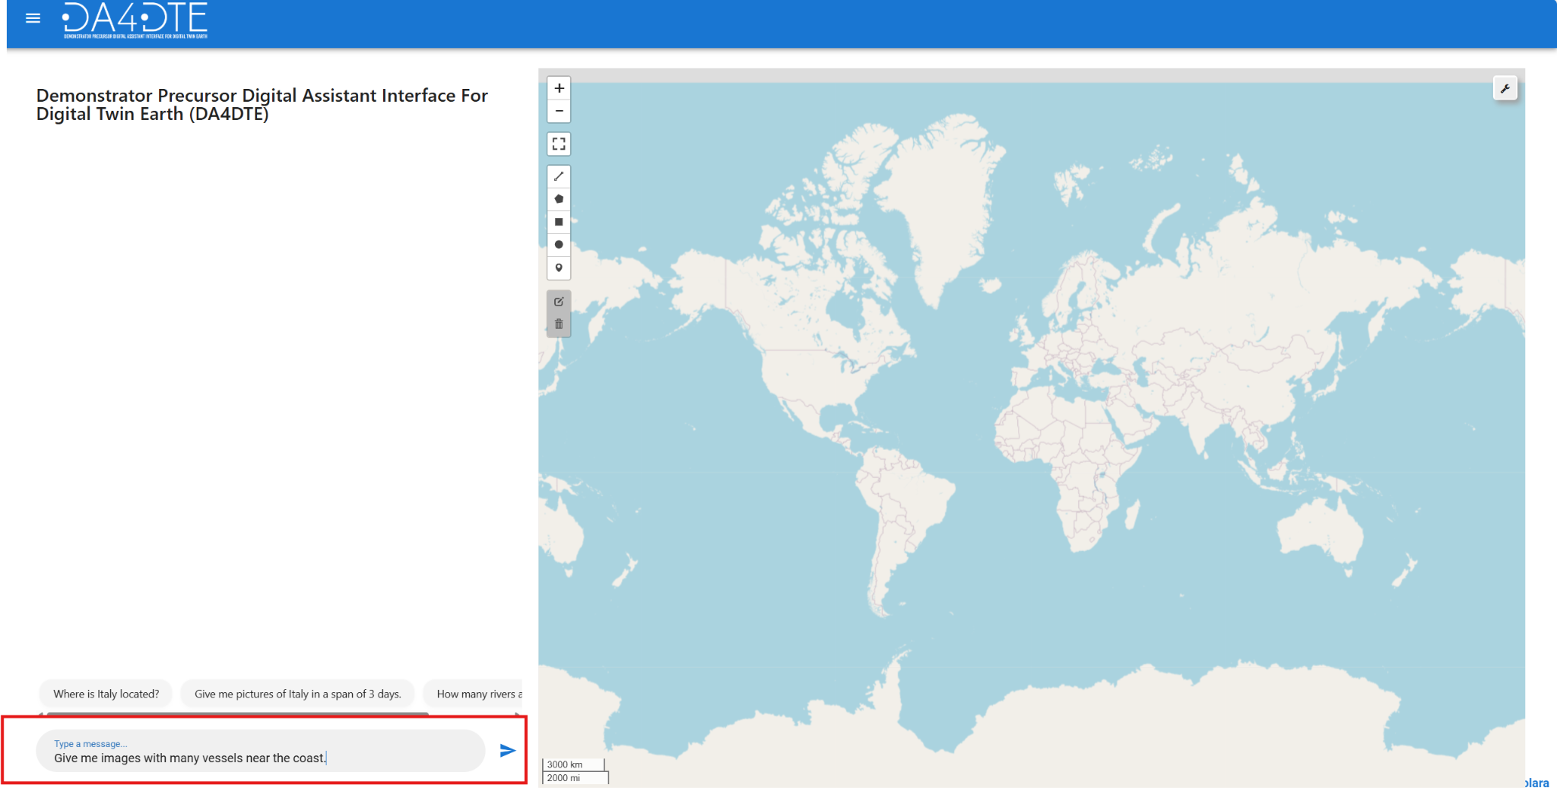

- Response: The Search by image engine returns the images depicting vessels near a coastal area.
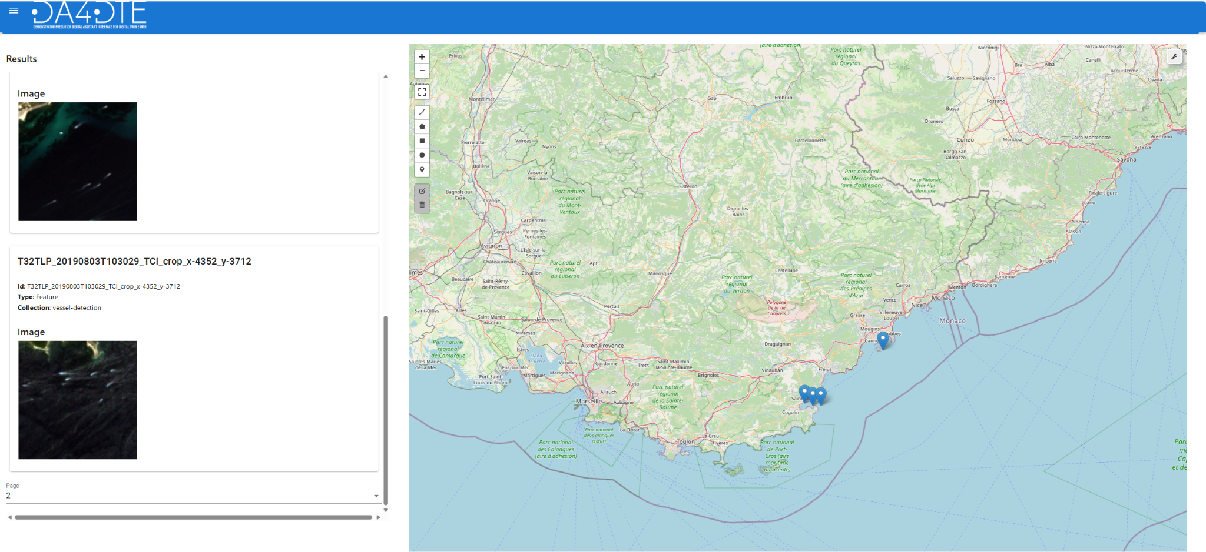

Conclusion:
With this guide, you should now be equipped to effectively navigate and utilize the features of the DA4DTE frontend user interface. Happy exploring!

